
HWA CHONG INSTITUTION
C2 Preliminary Examination
Higher 2

CANDIDATE NAME |  |  | CT GROUP | 09S

CHEMISTRY  Paper 3 Free Response  Candidates answer on the separate paper.  Additional Materials: Answer Paper  Data Booklet. | 9647/03  16 September 2010  2 hours

READ THESE INSTRUCTIONS FIRST
Write your name and class on all the work you hand in.
Write in dark blue or black pen.
You may use a soft pencil for any diagrams, graphs or rough working.

Answer any four questions.
Begin each question on a new piece of paper.
A Data Booklet is provided.
You are reminded of the need for good English and clear presentation in your answers.

The number of marks is given in brackets [ ] at the end of each question or part question.
At the end of the examination, fasten all your work securely together.
Write down the question numbers for the questions that you have attempted on the cover page provided.

Answer any four questions.

1 | (a) | Phosphorus is a non-metal which was discovered by the German physician Hennig Brand in 1669. In his experiments, Brand found that the white material (white phosphorus) glowed in the dark and spontaneously burst into a bright white flame when burned in air.
 |  | (i) | Write equations, including state symbols, for the reactions that occur when a sample of phosphorus is burned in excess oxygen, and water is added to the resulting oxide.
 |  | (ii) | Suggest the pH of the aqueous solution formed.
 |  |  | [3]
 | (b) | The equation below shows how phosphorus pentachloride, PCl₅, reacts with a limited amount of water.  PCl₅(s) + H₂O(l) → POCl₃(l) + 2HCl(g) ΔH_{r}  The following data are given:  Standard enthalpy change of formation of PCl₅(s) = −444 kJ mol⁻¹  Standard enthalpy change of formation of POCl₃(l) = −1186 kJ mol⁻¹  Standard enthalpy change of formation of HCl(g) = −92 kJ mol⁻¹  Standard enthalpy change of combustion of H₂(g) = −286 kJ mol⁻¹
 |  | (i) | What do you understand by the term standard enthalpy change of formation of POCl₃(l)?
 |  | (ii) | Use the given data to draw a suitable energy cycle for the above reaction and use it to calculate ΔH_{r}.
 |  |  | [4]
 | (c) | Phosphorus pentachloride, PCl₅, is involved in the following reaction scheme.
 | 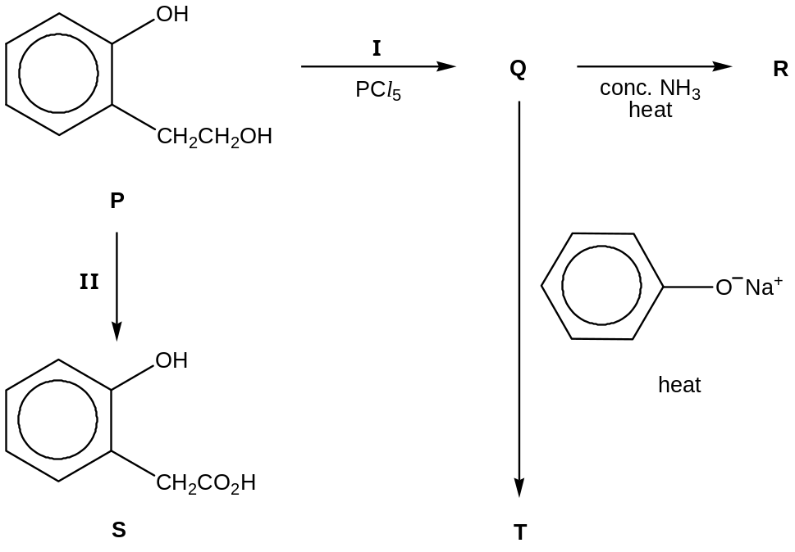
 |  | (i) | Draw the structures of compounds Q, R and T.
 |  | (ii) | State the reagents and conditions needed for reaction II.
 |  | (iii) | State the reagents and conditions needed to convert S to P.
 |  | (iv) | Suggest and explain one safety precaution you should employ when using PCl₅ in reaction I.
 |  |  | [6]
 | (d) | Phosphates have an amazing array of applications in home and industry. For example, sodium hydrogenphosphate, Na₂HPO₄, is a laxative ingredient and is used to adjust the acidity of boiler water.
A buffer solution is made by mixing 500 cm³ of 0.30 mol dm^{–3} NaH₂PO₄ with 100 cm³ of 0.20 mol dm^{–3} Na₂HPO₄.

For the equilibrium:

H₂PO₄–(aq)  H⁺(aq) + HPO₄^{2–}(aq) K_{a} = 6.30 × 10^{–7} mol dm^{–3}
 |  | (i) | Calculate the pH of the buffer solution.
 |  | (ii) | Write ionic equations to show how this buffer solution reacts with
 |  |  | - added H⁺(aq) ions,
 |  |  | - added OH–(aq) ions.
 |  |  | [4]
 | (e) | The structure of hydrogenphosphate ion, HPO₄^{2–}, is shown below.  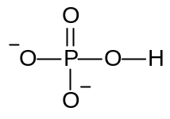  When two hydrogenphosphate ions undergo a condensation reaction, they form a diphosphate ion, P₂O₇^{4–} and a water molecule.
 |  | (i) | Draw the structure of P₂O₇^{4–}.
 |  | (ii) | State the shape of the ion about each central atom.
 |  |  | [3]
 |  |  | [Total: 20]

2 | (a) | Esterification is commonly carried out using acids as catalysts.  5-hydroxypentanoic acid can undergo intramolecular esterification to form a cyclic ester.
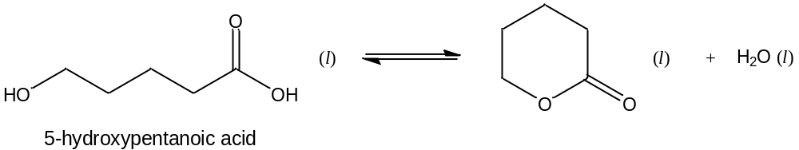
 |  | This esterification system exists in a dynamic equilibrium.
 |  | (i) | Explain what is meant by the term dynamic equilibrium.
 |  | (ii) | Write an expression for the equilibrium constant, K_{c}, for this esterification reaction.
 |  | (iii) | In an experiment, 2.0 mol of 5-hydroxypentanoic acid was allowed to undergo esterification.
 |  |  | Given that 5% of 5-hydroxypentanoic acid remained at equilibrium and the total volume of the mixture remained constant at 200 cm³, calculate the K_{c} for this reaction.
 |  | (iv) | In the reverse reaction, i.e. the hydrolysis of the cyclic ester,
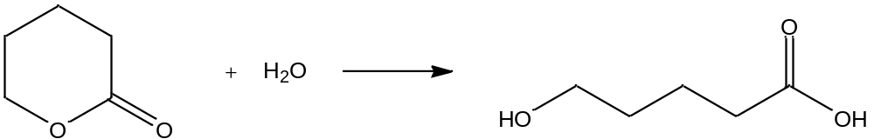
the rate of the reaction gradually increases at first, but then decreases.

Explain why this is so.
 |  |  | [6]
 | (b) | Enzymes are proteins which act as biological catalysts in the body. They speed up various cellular reactions which would otherwise be too slow to occur at normal physiological conditions.
 |  | Esterases are examples of enzymes which catalyse the hydrolysis of esters into alcohols and carboxylic acids.
 |  | (i) | Explain briefly how an enzyme such as esterase can function as a biological catalyst.
 |  | (ii) | The secondary structure of an esterase consists of segments of α-helix.
 |  |  | Describe the α-helix structure with the aid of a suitable diagram.
 |  | (iii) | The diagram below shows the structure, at pH 7, of a fragment from an esterase which contains three amino acid residues, E, F and G.  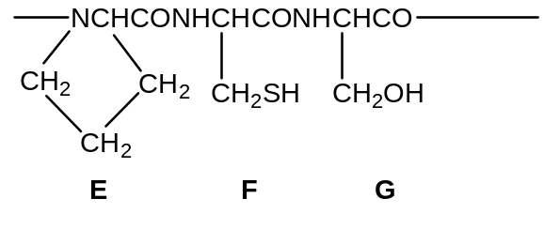  Draw the structure of E that could be obtained after heating the protein fragment with dilute hydrochloric acid.
 |  | (iv) | Describe, with the aid of diagrams, how each of the side chains of F and G in (b)(iii) could be involved in the maintenance of the tertiary structure of the protein.
 |  |  | [7]
 | (c) | A hot solution of tartaric acid, HO₂CCH(OH)CH(OH)CO₂H, undergoes a redox reaction with hydrogen peroxide, giving a very slow stream of carbon dioxide. When a few drops of an aqueous cobalt(II) salt are added, the colour turns pink. Soon the colour of the solution turns green, and a vigorous effervescence of carbon dioxide takes place. When the reaction stops, the pink colour is restored.
 |  | (i) | Suggest the role for the cobalt(II) salt.
 |  | (ii) | Give four reasons which support the answer in (c)(i).
 |  | (iii) | With the aid of relevant half-equations, construct an equation for the overall reaction.
 |  |  | (You may use C₄H₆O₆ to represent tartaric acid in your equation.)
 |  |  | [7]
 |  |  | [Total: 20]

3 | (a) | The chlorides of magnesium and silicon differ in their reactions with water. Describe and explain these differences in terms of their structure and bonding, writing equations for any reactions that occur.
 |  |  | [4]
 | (b) | Describe what you would see when a red-hot rod is plunged into separate jars containing HCl gas and HI gas. Account for the observations using appropriate data from the Data Booklet.
 |  |  | [2]
 | (c) | Chlorine is produced commercially via electrolysis of concentrated sodium chloride, also known as brine, using inert electrodes. This process may be represented by the following equation:  electrolysis  2NaCl(concentrated) + 2H₂O(l) 2NaOH(aq) + Cl₂(g) + H₂(g)
 |  | (i) | Give the ion-electron equation for the reactions which occur at each of the electrodes in the electrolysis of brine.
 |  | (ii) | Calculate the mass of chlorine produced if a current of 5 A was passed for 7 hours through the electrolytic cell.
 |  | (iii) | Using relevant data from the Data Booklet, suggest why dilute sodium chloride solution cannot be used in the production of chlorine.
 |  |  | [6]
 | (d) | (i) | If the electrolytic cell in (c) is stirred in the cold, two of the products will react. State the type of reaction involved and write an equation, with state symbols, for the reaction.
 |  | (ii) | If the electrolytic cell in (c) is kept at higher temperatures, the same two products react to produce a different chlorine-containing compound. Write an equation, with state symbols, for this reaction.
 |  |  | [3]

 | (e) | Grignard reagents can be prepared by the reaction of magnesium with a halogenoalkane or halogenoarene, using dry ether as the solvent:
 |  | The carbon-magnesium bonds in Grignard reagents are highly polar. This property makes the Grignard reagent very useful in organic synthesis as it can react with other polar organic molecules to form a carbon-carbon bond. An example of a Grignard reagent reacting with a ketone to form an alcohol via a two stage process is given below:
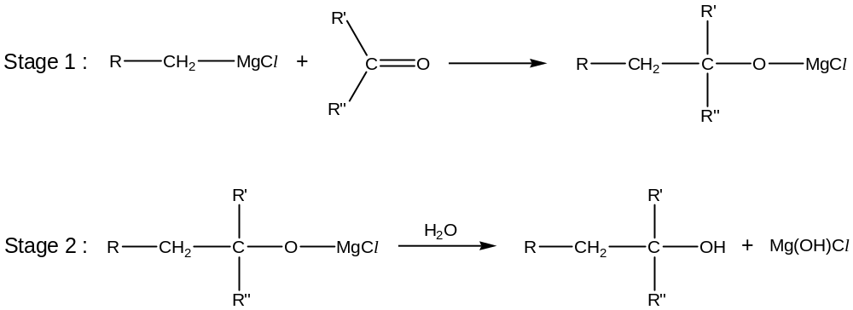
 |  | (i) | Suggest the type of reaction occuring between the Grignard reagent and the ketone in Stage 1.
 |  | (ii) | The tertiary alcohol 3-methylpentan-3-ol is used in the manufacture of flavouring agents. A possible synthetic route, starting from chloromethane and involving a Grignard reagent, is given below:
 |  | 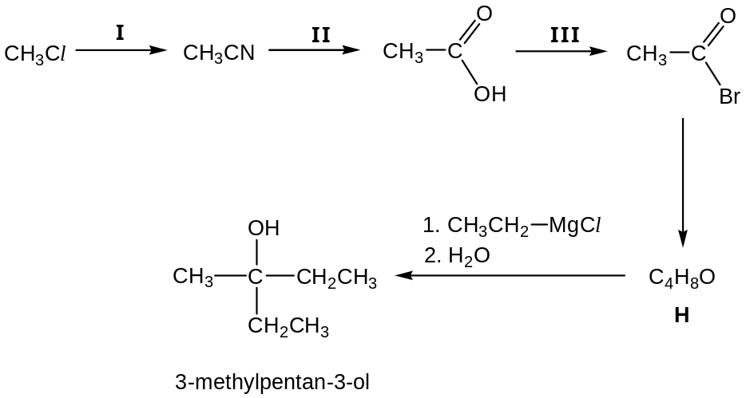
 |  |  | State the reagents and conditions required for reactions I, II and III, and give the structure for compound H.
 |  |  | [5]
 |  |  | [Total: 20]

4 | (a) | Depending on the oxidation state of manganese, compounds of manganese have various colours and they are used industrially as pigments for the colouring of ceramics and glass.
 |  | The absorption spectrum of the compound K₃[Mn(CN)₆] shows a maximum at a wavelength around 490 nm (blue-green region).
 |  | (i) | State the oxidation number of manganese in this compound.
 |  | (ii) | Suggest the colour of this compound.
 |  | (iii) | Explain how the colour of this compound arises.
 |  |  | [4]
 | (b) | Potassium manganate(VII) plays an important role in analytical chemistry.  The figures below show the standard electrode potentials, E○, of various redox half reactions. For example, in Figure 1, the line shows that the E○ for MnO₄⁻/Mn²⁺ half-cell is +1.52 V.
7  6  5  4  3  2  1  0  −1  −2  Oxidation number  MnO₄⁻  Mn²⁺  +1.52 V  −0.2  0.0  +0.2  +0.4  +0.6  +0.8  +1.0  +1.2  +1.42  +1.6  +1.8  E○ / V |  |  | SO₄²⁻  SO₃²⁻  S₂O₆²⁻  S₂O₃²⁻  S₈  S₄O₆²⁻  7  6  5  4  3  2  1  0  −1  −2  Oxidation number  −0.2  0.0  +0.2  +0.4  +0.6  +0.8  +1.0  +1.2  +1.42  +1.6  +1.8  E○ / V
Figure 1
Figure 2

 |  | (i) | Use the lines in Figure 2 to predict what sulfur-containing species might be formed from sodium sulfite, Na₂SO₃, when it is titrated with acidified potassium manganate(VII) solution. Give a reason for your prediction.
 |  | (ii) | During an actual experiment, 25.0 cm³ of 0.020 mol dm⁻³ acidified potassium manganate(VII) was found to react completely with 12.5 cm³ of 0.10 mol dm⁻³ sodium sulfite. From these results, deduce the oxidation number of sulfur in the sulfur-containing species at the end of the reaction.
 |  |  | [4]
 | (c) | In another experiment, a solution of iron(II) sulfate was titrated against 0.020 mol dm⁻³ acidified potassium manganate(VII), maintaining a constant [H⁺] throughout the titration. The electrode potential was measured against a standard hydrogen electrode and the following data was obtained.
Volume of KMnO₄(aq) added / cm³ | E at 25 ºC / V
20.0 | +0.734
40.0 | +0.760
60.0 | +0.780
80.0 | +0.806
120.0 | +1.512
140.0 | +1.515

The electrode potential of the mixture at 25 ºC, E, is given by the expression

E = E○ (Fe³⁺/Fe²⁺) + 0.0257 ln 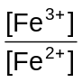
 |  | (i) | Using the given expression and relevant information from the Data Booklet, determine the value of E when [Fe²⁺] and [Fe³⁺] are equal.
 |  | (ii) | Estimate the volume of KMnO₄ added which corresponds to your value of E in (c)(i).
 |  | (iii) | Explain why there is a rapid increase in the value of E between 80.0 cm³ and 120 cm³ of KMnO₄.
 |  | (iv) | Suggest why it was necessary to maintain a constant [H⁺] in this experiment.
 |  |  | [4]
 | (d) | Potassium manganate(VII) is used in organic chemistry in the identification of compounds.  A compound J, C₁₁H₁₄, exhibits cis-trans isomerism but does not possess any chiral carbon. Oxidation of J with hot acidified potassium manganate(VII) gives K, C₉H₈O_{3.} K reacts with aqueous alkaline iodine to give a yellow precipitate and a residual solution. Upon acidification, the residual solution yields benzene-1,2-dicarboxylic acid:  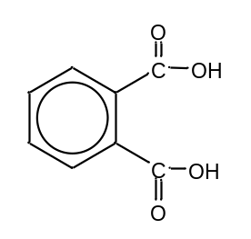  J reacts with steam at 300 ºC and 60 atm in the presence of concentrated phosphoric acid to give L, C₁₁H₁₆O. L is an optically active compound which does not react with aqueous alkaline iodine.  Deduce the structures of J, K and L based on these observations.
 |  |  | [8]
 |  |  | [Total: 20]
5 | (a) | Norsethite, Ba_{x}Mg_{y}(CO₃)_{z}, is a mineral consisting of barium carbonate and magnesium carbonate. The decomposition temperatures of barium carbonate and magnesium carbonate are 1350 °C and 540 °C respectively.
 |  | (i) | Account for the difference in decomposition temperatures of barium carbonate and magnesium carbonate.  Write equation(s) for any reaction(s) that occur on heating norsethite to 800 ºC.
 |  | (ii) | A sample of pure norsethite was heated strongly at 1500 °C until no further change occurred. The gas evolved was collected and found to occupy a volume of 72 cm³ at room temperature and pressure. The residue was a white powder which was dissolved in dilute nitric acid. On addition of aqueous sodium sulfate to the resulting solution, a white precipitate of barium sulfate was formed. The precipitate was dried and its mass was found to be 0.35 g.
Write an equation, with state symbols, to represent the decomposition of norsethite, giving your answer in terms of x, y, and z. Hence deduce the values of x, y and z.
[M_{r} of norsethite was found to be less than 300.]
 |  | (iii) | In the presence of carbon, further heating of the residue would cause the formation of carbon monoxide as a by-product.
 |  |  | Explain why carbon monoxide is poisonous.
 |  |  | [8]
 | (b) | Explain the following observations.
 |  | (i) | Iron can exhibit variable oxidation states in its compounds but calcium only exhibits an oxidation state of +2 in all its compounds.
 |  | (ii) | The melting points of iron and calcium are 1536 °C and 839 °C respectively.
 |  |  | [3]
 | (c) | Magnesium hydroxide is sparing soluble in water. The pH of a saturated solution of Mg(OH)₂ is 10.5 at 25 ºC.  Calculate
 |  | (i) | the solubility of Mg(OH)₂ in g dm⁻³ at 25 ºC,
 |  | (ii) | the K_{sp} of Mg(OH)₂ at 25 ºC, stating its units,
 |  |  | [3]
 | (d) | Group II salts of carboxylic acids decompose to give the metal carbonate and a carbonyl compound. For example, calcium ethanoate produced propanone.  (CH₃CO₂)₂Ca  CaCO₃ + (CH₃)₂CO  When this reaction is carried out by heating a mixture of calcium ethanoate and calcium methanoate, an acidic gas and a mixture of three carbonyl compounds, A, B and C, are formed.
 |  | (i) | Both A and B but not C react with Tollens’ reagent. Only A and C react with alkaline aqueous iodine to give a yellow precipitate.
 |  |  | Deduce the identities of A, B and C.
 |  | (ii) | A was warmed with Tollens’ reagent and the organic product formed, D, is isolated and made to react with CH₃CH₂Br forming a sweet-smelling liquid, C₄H₈O₂.
 |  |  | Suggest the identity of D and name the type of reaction that D has undergone.
 |  | (iii) | When B is reacted with excess hot acidified potassium manganate(VII), no organic product remains. Explain.
 |  |  | [6]
 |  |  | [Total: 20]

BLANK PAGE

